Transaction State
In database systems, a transaction is a sequence of one or more operations performed as a single logical unit of work. A transaction state refers to the different stages a transaction can be in during its lifecycle in the database system. Understanding these states is crucial for ensuring ACID properties (Atomicity, Consistency, Isolation, Durability).
Here’s a detailed breakdown of transaction states:
1. Active State
- The transaction is currently executing its operations.
- The database is performing read/write operations.
- At this stage, the transaction has not yet completed.
- If an error occurs, it may abort.
Example: A bank transaction is debiting $100 from account A and crediting account B. Until both operations are complete, the transaction is active.
2. Partially Committed
- The transaction has executed its final operation but changes are not yet permanently recorded in the database.
- The system is preparing to commit the transaction.
- If the system crashes at this point, the transaction may not be committed.
3. Committed
- The transaction has successfully completed, and all changes are permanently saved in the database.
- Once committed, changes cannot be undone by the transaction itself.
Key point: Committed transactions ensure durability.
4. Failed
- The transaction cannot proceed due to an error or violation (like a constraint violation).
- The transaction must be rolled back to undo any partial changes made.
5. Aborted (or Rolled Back)
- All operations of the transaction are undone.
- The database is restored to its previous consistent state.
- The transaction may be restarted if required.
6. Terminated
- The transaction is in a final state—either committed or aborted.
- No further operations are allowed.
Transaction State Diagram
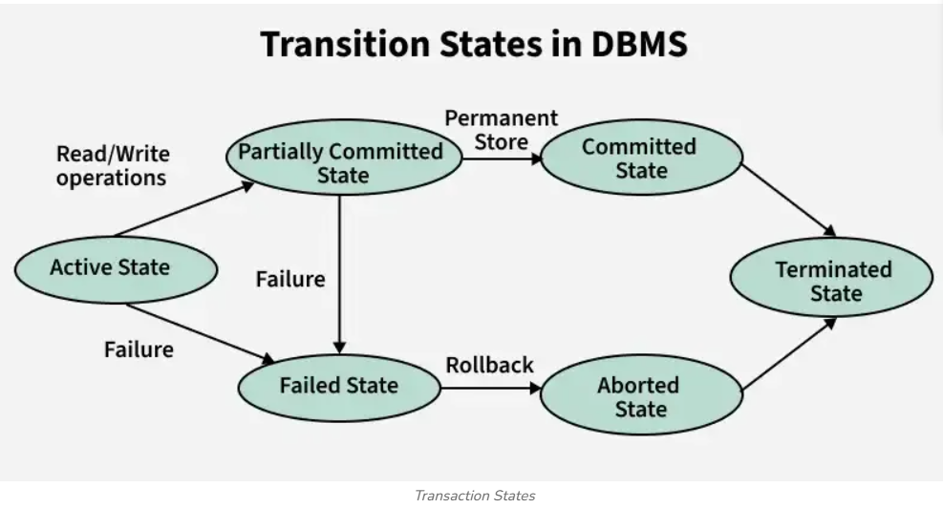Summary Table
State | Description
Active | Transaction is executing operations
Partially Committed | Final operation done, not yet permanent
Committed | Changes permanently saved
Failed | Transaction cannot continue
Aborted | Changes undone, database restored
Terminated | Transaction has ended (committed or aborted)
 | ACID properties
The ACID properties are a set of principles that guarantee reliable processing of database transactions. They ensure that the database remains consistent, accurate, and reliable, even in the case of errors, failures, or concurrent access. ACID stands for Atomicity, Consistency, Isolation, and Durability. Here’s a detailed explanation:

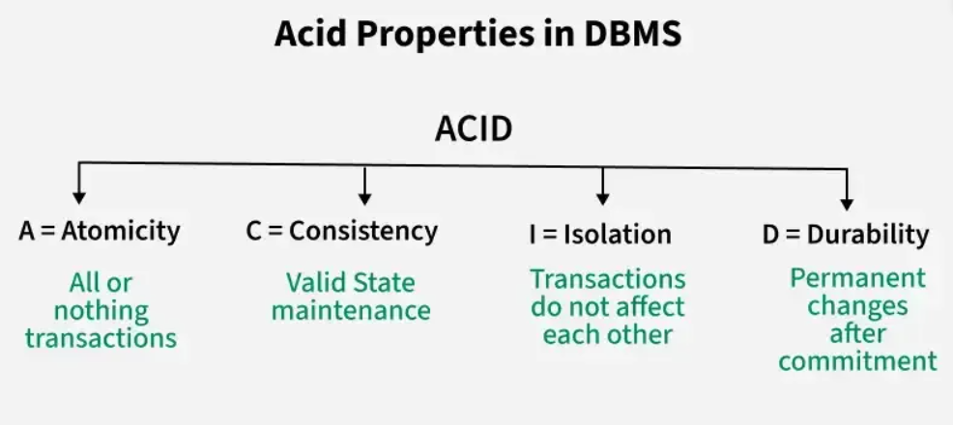
1. Atomicity
- Definition: A transaction is treated as a single, indivisible unit. It either completes fully or does not happen at all.
- Purpose: Prevents partial updates that could corrupt the database.
- Example: Transferring ₹100 from Account A to Account B:
  - Step 1: Deduct ₹100 from A
  - Step 2: Add ₹100 to B
  - If Step 2 fails, Step 1 is rolled back. The database remains unchanged.
2. Consistency
- Definition: A transaction must transform the database from one valid state to another, maintaining all defined rules, constraints, and integrity.
- Purpose: Ensures the database always obeys its integrity rules.
- Example:
  - Rule: Account balance cannot be negative.
  - If a transaction would violate this, it is aborted, preserving consistency.
3. Isolation
- Definition: Transactions execute independently of each other. Intermediate states of a transaction are invisible to other concurrent transactions.
- Purpose: Prevents conflicts when multiple users access or modify the database simultaneously.
- Example:
  - Two users update the same bank account at the same time.
  - Isolation ensures the final balance is correct, as if the transactions occurred one after the other.
4. Durability
- Definition: Once a transaction is committed, its changes are permanent, even in the event of a system crash.
- Purpose: Guarantees data is not lost after a successful transaction.
- Example:
  - After transferring money, the updated balances remain safe, even if the database server crashes immediately afterward.
✅ Summary Table:
Property | Meaning | Example
Atomicity | All or nothing | Money transfer fails → rollback
Consistency | Keeps database in a valid state | No negative balances allowed
Isolation | Transactions do not interfere with each other | Concurrent updates handled correctly
Durability | Committed changes are permanent | Changes survive system crash
Concurrent Executions
1. Definition
Concurrent execution refers to the situation where multiple transactions are executed simultaneously in a database system.
- These transactions overlap in time.
- The goal is to improve system performance and utilize resources efficiently.
- Despite concurrent execution, the database must remain consistent.
In short: multiple transactions at the same time, but the database still behaves correctly.
2. Why Concurrent Execution is Needed
- Performance: Multiple transactions can use CPU and I/O resources simultaneously.
- Throughput: More transactions can be completed per unit time.
- Responsiveness: Users don’t have to wait for other transactions to finish.
3. Problems with Concurrent Execution
Concurrent execution can lead to anomalies if not controlled properly. The main issues are:
- Lost Update
Two transactions read the same data and update it, but one update is lost.
Example: Two people withdraw from the same bank account at the same time.
- Temporary Inconsistency / Dirty Read
One transaction reads uncommitted changes from another transaction.
Example: Reading an amount before another transaction finishes updating it.
- Uncommitted Dependency (Cascading Rollback)
If a transaction fails after another has read its changes, all dependent transactions may also have to roll back.
- Inconsistent Retrieval
A transaction reads some parts of the database while another transaction is modifying it, leading to inconsistent data.
4. Ensuring Safe Concurrent Execution
To prevent anomalies, concurrency control techniques are used:
a) Lock-Based Protocols
- Shared (S) lock: For reading data.
- Exclusive (X) lock: For writing data.
- Two-Phase Locking (2PL): Ensures serializability.
  - Growing phase: Acquire locks.
  - Shrinking phase: Release locks.
b) Timestamp-Based Protocols
- Assign a timestamp to each transaction.
- Older transactions get priority over newer ones to maintain order.
c) Optimistic Concurrency Control
- Transactions execute without restrictions.
- Before commit, check for conflicts; if conflict exists, roll back.
5. Serializability
- Goal: Concurrent execution should produce the same result as some serial execution of the transactions.
- Types of Schedules:
  - Serial Schedule: Transactions executed one after another.
  - Concurrent Schedule: Transactions interleave their operations.
  - Conflict-Serializable Schedule: Can be transformed into a serial schedule by swapping non-conflicting operations.
6. Example
Suppose we have two transactions:
T1:
Read(A)
A = A + 100
Write(A)
T2:
Read(A)
A = A * 2
Write(A)
- If executed serially (T1 → T2 or T2 → T1), final result is predictable.
- If executed concurrently without control, final value may be incorrect (lost update problem).
serializability
1. What is Serializability?
Serializability is the concept of ensuring correctness in concurrent transactions in a database.
When multiple transactions execute concurrently, their operations (like read/write) can interleave. Serializability ensures that the final result of these interleaved transactions is the same as some serial execution (i.e., one transaction after another, without overlapping).
In simple terms:
"Even if transactions run at the same time, the outcome should be as if they ran one by one in some order."
2. Why is it Important?
- Prevents inconsistency in the database.
- Maintains ACID properties, especially consistency.
- Avoids problems like lost updates, dirty reads, and uncommitted data issues.
3. Types of Serializability
There are mainly two types:
A. Conflict Serializability
- Focuses on conflicting operations: operations that cannot be swapped without affecting the result.
- Conflicts occur when two transactions access the same data item, and at least one is a write.
- Example conflicts:
  - Read(A) and Write(A) → conflict
  - Write(A) and Read(A) → conflict
  - Write(A) and Write(A) → conflict
- A schedule (sequence of operations) is conflict serializable if it can be transformed into a serial schedule by swapping non-conflicting operations.
Conflict Graph (Precedence Graph):
- Nodes → Transactions
- Edge T1 → T2 if T1’s operation precedes and conflicts with T2’s operation
- No cycle → schedule is conflict serializable
B. View Serializability
- Focuses on data values read/written, not just conflicts.
- A schedule is view serializable if:
  - It reads the same initial values as in some serial schedule.
  - It reads values written by the same transaction as in some serial schedule.
  - The final write of each data item is the same as in some serial schedule.
- All conflict-serializable schedules are view-serializable, but not all view-serializable schedules are conflict-serializable.
4. Example
Transactions:
T1: R(A), W(A)
T2: R(A), W(A)
Schedule S1 (Concurrent):
T1: R(A)
T2: R(A)
T1: W(A)
T2: W(A)
- Check conflicts:
  - T1 W(A) and T2 W(A) → conflict
- Build precedence graph:
  - Edge T1 → T2 or T2 → T1 depending on order
- If cycle exists → Not conflict serializable
- If no cycle → Conflict serializable
5. Key Points
- Serializability ensures consistency in concurrent transactions.
- Conflict serializability is easier to check using precedence graphs.
- View serializability is more general but harder to check.
- All serial schedules are trivially serializable.
Recoverability
1. Definition of Recoverability
Recoverability is a property of a schedule of transactions in a database, which ensures that the database can be recovered to a consistent state after a transaction failure.
In other words:
If a transaction fails after reading or writing data, the system should be able to undo or redo operations so that the database remains consistent.
2. Why Recoverability is Important
- Transactions may abort due to errors, deadlocks, or system crashes.
- If one transaction reads data modified by another uncommitted transaction, a failure in the first transaction can leave the database in an inconsistent state.
- Recoverability ensures no cascading inconsistencies.
3. Key Concepts
a) Cascadeless Schedule
A schedule is cascadeless if a transaction only reads data written by committed transactions.
- This avoids cascading aborts, where the failure of one transaction forces multiple other transactions to abort.
b) Recoverable Schedule
A schedule is recoverable if, whenever a transaction Tj reads data written by Ti, Ti commits before Tj commits.
- This ensures that if Ti fails, Tj can be safely aborted to maintain consistency.
c) Non-Recoverable Schedule (Dangerous)
If Tj reads data from Ti and Tj commits before Ti, then Ti fails → database inconsistency occurs.
- These schedules must be avoided in DBMS design.
4. Example
Consider two transactions:
- T1: Write(A) → Commit
- T2: Read(A) → Commit
Recoverable Schedule:
T1: Write(A)
T2: Read(A)
T1: Commit
T2: Commit
- T2 reads A after T1 writes it, but T2 commits after T1 → recoverable.
Non-Recoverable Schedule:
T1: Write(A)
T2: Read(A)
T2: Commit
T1: Commit
- T2 commits before T1 → if T1 fails, T2 has already committed inconsistent data → non-recoverable.

5. Summary
Term | Definition
Recoverable | Tj commits only after Ti commits if Tj read data from Ti
Cascadeless | Tj only reads data written by committed transactions
Non-Recoverable | Tj commits before Ti, and Tj read data from Ti
Implementation of Isolation
1. Concept of Isolation
- Isolation prevents uncommitted changes of one transaction from being visible to other transactions.
- It protects against the following concurrency problems:
  - Dirty reads: Reading uncommitted data from another transaction.
  - Non-repeatable reads: A value read twice in the same transaction changes because another transaction updated it.
  - Phantom reads: A transaction reads a set of rows satisfying a condition; another transaction inserts/deletes rows that affect that condition.
- Isolation levels in SQL (from least strict to most strict):
  - Read Uncommitted – lowest isolation, allows dirty reads.
  - Read Committed – no dirty reads, but non-repeatable reads can occur.
  - Repeatable Read – no dirty or non-repeatable reads, but phantom reads can occur.
  - Serializable – highest isolation, transactions behave as if executed serially.
2. Implementation Techniques
Isolation is implemented using locking or versioning techniques.
A. Lock-Based Implementation
- Two-Phase Locking (2PL) is the most common.
- Two phases:
  - Growing phase: Transaction acquires all locks it needs (shared for read, exclusive for write).
  - Shrinking phase: Transaction releases locks; no new locks can be acquired.
- Types of locks:
  - Shared lock (S): For reading. Multiple transactions can hold S lock on the same data.
  - Exclusive lock (X): For writing. Only one transaction can hold X lock on a data item.
- Example:
- Transaction T1:
- acquire S lock on A
- read A
- release S lock on A

- Transaction T2:
- acquire X lock on A
- write A
- release X lock on A
- Ensures serializability by preventing conflicting operations from occurring simultaneously.
B. Timestamp-Based Implementation
- Each transaction gets a unique timestamp.
- Rules:
  - Older transactions have priority over newer ones.
  - If a newer transaction tries to read/write an item already modified by an older transaction, the newer may be rolled back or delayed.
- Example:
  - T1 (timestamp = 1) wants to write A.
  - T2 (timestamp = 2) wants to read A.
  - T2 must wait until T1 commits to ensure isolation.
C. Multiversion Concurrency Control (MVCC)
- Each write creates a new version of a data item.
- Readers can access the previous committed version, so readers don’t block writers.
- Commonly used in databases like PostgreSQL, Oracle, MySQL (InnoDB).
- Example:
- T1 writes A → version 2 of A
- T2 reads A → still sees version 1 until T1 commits
- Provides high concurrency and avoids most locking conflicts.
3. Summary Table
Technique | How It Works | Pros | Cons
Lock-Based | Locks items (S/X) | Simple, serializable | Can cause deadlocks
Timestamp-Based | Orders transactions by timestamps | Avoids some deadlocks | Can abort transactions frequently
MVCC | Maintains multiple versions | High concurrency, no reader-writer block | Uses more storage

4. Example in SQL (Using Isolation Levels)
-- Set transaction isolation level
SET TRANSACTION ISOLATION LEVEL SERIALIZABLE;

BEGIN TRANSACTION;

-- Transaction 1
SELECT balance FROM accounts WHERE account_id = 101;

-- Transaction 2 (running concurrently)
UPDATE accounts SET balance = balance + 500 WHERE account_id = 101;

COMMIT;
- With SERIALIZABLE, T2 must wait for T1 to finish to maintain isolation.
Testing for Serializability
1. What is Serializability?
A schedule is serializable if its outcome (final database state) is equivalent to some serial schedule, i.e., transactions are executed one after another without overlapping.
Two common types:
- Conflict Serializability – checks whether conflicting operations can be reordered without changing the result.
- View Serializability – checks whether the transactions read and write the same data values as some serial schedule.
2. Conflict Serializability
Step 1: Identify Conflicts
Two operations conflict if:
- They belong to different transactions, and
- They access the same data item, and
- At least one is a write.
So possible conflicts:
Operation Pair | Conflict?
R(A) and R(A) | No
R(A) and W(A) | Yes
W(A) and R(A) | Yes
W(A) and W(A) | Yes
Step 2: Build a Precedence Graph (Serialization Graph)
- Nodes: Transactions (T1, T2, …)
- Edges: Draw T1 → T2 if T1 has an operation that conflicts and precedes an operation of T2.
Step 3: Check for Cycles
- Acyclic graph: Schedule is conflict-serializable
- Cycle exists: Schedule is not conflict-serializable
Example:
Schedule ( S ):
T1: R(A) W(A)
T2: R(A) W(A)
- Conflicts:
- T1 W(A) → T2 R(A) ✅
- T1 W(A) → T2 W(A) ✅
- T2 W(A) → T1 W(A) ✅ (also a conflict)
- Graph:
- T1 → T2
- T2 → T1
Cycle exists → Not conflict-serializable
3. View Serializability
Even if conflict serializability fails, a schedule may still be view-serializable.
Steps:
- Initial Reads: Check that the first read of a data item comes from the same transaction as in the serial schedule.
- Reads-from: Each read reads the same value as in some serial schedule.
- Final Writes: The transaction that writes the final value of a data item is the same as in the serial schedule.
If all these hold, the schedule is view-serializable.
- Conflict Serializability: Check conflicts → build graph → no cycles = serializable.
- View Serializability: Check read/write equivalence → same final result = serializable.
- Every conflict-serializable schedule is view-serializable, but not vice versa.

lock-based protocols in databases
1. What are Lock-Based Protocols?
Lock-based protocols are a mechanism to ensure concurrency control in a database. When multiple transactions execute simultaneously, we need to prevent conflicts like lost updates, dirty reads, or inconsistent reads.
Idea: Before a transaction can read or write a data item, it must acquire a lock on that item. Locks control who can access what and when.
2. Types of Locks
Locks can be of two main types:
a) Shared Lock (S-lock)
- Used when a transaction reads a data item.
- Multiple transactions can share a shared lock simultaneously.
- Example: Transaction T1 and T2 both want to read data item X → both can hold a shared lock on X.
b) Exclusive Lock (X-lock)
- Used when a transaction writes a data item.
- Only one transaction can hold an exclusive lock on a data item at a time.
- Example: Transaction T1 wants to write data item X → T2 must wait until T1 releases the lock.
3. Lock Compatibility Table
Lock Requested | Existing Lock | Can it be Granted?
S | S | Yes
S | X | No
X | S | No
X | X | No
- S + S → ok (shared reading is allowed)
- Any X involved → wait (writing is exclusive)
4. Basic Lock-Based Protocols
a) Two-Phase Locking (2PL)
- Guarantees serializability (transactions appear to run one after the other).
- Two phases:
  - Growing phase: Transaction acquires all required locks (no lock is released yet).
  - Shrinking phase: Transaction releases locks (no new locks are acquired).
- Example:
  - T1 acquires X-lock on A → reads/writes → releases lock on A
  - Ensures no conflicts with T2
Variants of 2PL:
- Basic 2PL: Just growing and shrinking.
- Strict 2PL: All X-locks are held until transaction commits.
- Rigorous 2PL: All locks (S and X) held until commit.
b) Conservative 2PL (C2PL)
- Transaction pre-acquires all locks before execution.
- Prevents deadlocks but reduces concurrency.

Deadlocks
- Lock-based protocols can cause deadlocks: two transactions waiting indefinitely for each other.
- Example:
  - T1 holds lock on A, waiting for B
  - T2 holds lock on B, waiting for A → deadlock
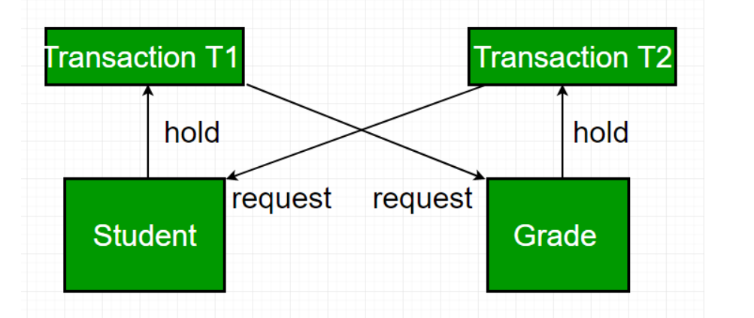
Necessary Conditions of Deadlock
For a deadlock to occur, all four of these conditions must be true:
- Mutual Exclusion: Only one transaction can hold a particular resource at a time.
- Hold and Wait: The Transactions holding resources may request additional resources held by others.
- No Pre-emption: The Resources cannot be forcibly taken from the transaction holding them.
- Circular Wait: A cycle of transactions exists where each transaction is waiting for the resource held by the next transaction in the cycle.

Deadlock Handling:
1. Deadlock Avoidance
Plan transactions in a way that prevents deadlock from occurring.
Methods:
- Access resources in the same order. For e.g., always access Students first, then Grades
- Use row-level locking and READ COMMITTED isolation level. It reduces chances, but doesn’t eliminate deadlocks. Completely
2. Deadlock Detection
If a transaction waits too long, the DBMS checks if it’s part of a deadlock.
Method: Wait-For Graph
- Nodes: Transactions
- Edges: Waiting relationships
- If there’s a cycle, a deadlock exists. It's mostly suitable for small to medium databases
3. Deadlock Prevention
For a large database, the deadlock prevention method is suitable. A deadlock can be prevented if the resources are allocated in such a way that a deadlock never occurs. The DBMS analyzes the operations whether they can create a deadlock situation or not, If they do, that transaction is never allowed to be executed.
Deadlock prevention mechanism proposes two schemes:
1. Wait-Die Scheme (Non-preemptive)
- Older transactions are allowed to wait.
- Younger transactions are killed (aborted and restarted) if they request a resource held by an older one
For example:
- Consider two transaction- T1 = 10 and T2 = 20
- If T1 (older) wants a resource held by T2 → T1 waits
- If T2 (younger) wants a resource held by T1 → T2 dies and restarts
Prevents deadlock by not allowing a younger transaction to wait and form a wait cycle.
2. Wound-Wait Scheme (Preemptive)
- Older transactions are aggressive (preemptive) and can force younger ones to abort.
- Younger transactions must wait if they want a resource held by an older one.
For example:
- Consider two transaction- T1 = 10 and T2 = 20
- If T1 (older) wants a resource held by T2 → T2 is killed, T1 proceeds.
- If T2 (younger) wants a resource held by T1 → T2 waits
Prevents deadlock by not allowing younger transactions to block older ones.

Failure classification in transactions:
Here’s a detailed breakdown:
1. Transaction Failures
These occur when an individual transaction cannot complete successfully. The main causes are:
a) System Crashes
- The database system or OS crashes during the execution of a transaction.
- Causes: power failure, OS crash, DBMS software crash.
- Effect: All uncommitted transactions at the time of crash must be rolled back to maintain consistency.
- Example: A transaction is transferring money, and the system crashes before committing the transfer. The partial transfer must be undone.
b) Transaction Errors (Logical or Application Errors)
- The transaction violates database rules or logical constraints.
- Causes:
  - Division by zero
  - Invalid input values
  - Constraint violations (e.g., inserting duplicate primary key)
- Effect: Transaction is aborted and rolled back.
- Example: Trying to withdraw more money than available in an account.
c) Deadlocks
- Two or more transactions wait indefinitely for resources held by each other.
- Resolution:
  - The DBMS detects deadlock and aborts one of the transactions.
- Effect: Aborted transaction is rolled back.
2. System Failures
Failures that affect the entire system rather than a single transaction.
a) Hardware Failures
- Disk crash, memory failure, network failure.
- Result: Transaction logs and data may be lost.
- Recovery: Use backup and logs to restore database to a consistent state.
b) Software Failures
- Bugs in DBMS, OS, or transaction management software.
- Effect: May leave the database in an inconsistent state.
- Recovery: Rely on transaction logs and checkpoints to rollback uncommitted transactions.
3. Media Failures
- Failures due to physical damage to storage devices (disk crash, corruption, fire, etc.).
- Effect: Loss of data on failed media.
- Recovery: Requires restoring from backup and replaying logs.

Storage in Transactions
Storage in transactions refers to how a database manages the data changes made by a transaction, ensuring durability and isolation. It involves:
a) Transaction Logs
- All updates made by transactions are recorded in a transaction log (write-ahead logging).
- If a system crashes, the log is used to redo committed transactions or undo uncommitted transactions.
- Example: UPDATE account SET balance = balance - 100 WHERE acc_no = 1; is logged before actual storage.
b) Temporary Storage / Buffer
- During execution, a transaction may temporarily store data in memory (buffers).
- Only when commit happens, the changes are written permanently to disk storage.
- Example: Oracle, MySQL, and SQL Server use buffer pools for this.
c) Undo/Redo Storage
- Undo: Stores old values to rollback a transaction if it fails.
- Redo: Stores new values to apply after a crash recovery.
d) Persistent Storage
- Once a transaction is committed, changes are stored permanently in the database files on disk.
- This ensures durability (D in ACID).
3. Storage Mechanisms
Transactions involve two main storage types:
Storage Type | Purpose
Main Memory / Buffer | Temporary storage for read/write operations during transaction execution.
Disk Storage / Database Files | Permanent storage for committed data.
Transaction Log | Keeps history of operations for rollback/redo in case of failure.
Undo/Redo Tablespaces | Oracle-specific storage for undoing or redoing operations.
4. Flow of Data in Transaction Storage
- Transaction starts → Data read/written in buffer memory.
- Changes logged in transaction log (for durability and recoverability).
- On commit, changes flushed to disk storage permanently.
- On abort/rollback, undo information used to revert changes in memory.
Recovery and Atomicity
1. Atomicity
Definition:
Atomicity is one of the ACID properties of a transaction. It ensures that a transaction is “all or nothing”: either all operations of the transaction are executed successfully, or none are applied to the database.
Key Points:
- If a transaction fails midway due to an error, the database must roll back to the state before the transaction started.
- Atomicity protects the database from partial updates.
Example:
Imagine a bank transfer of $100 from Account A to Account B. The transaction involves two steps:
- Deduct $100 from Account A.
- Add $100 to Account B.
If a failure occurs after step 1 (like a system crash), atomicity ensures that step 1 is undone, so Account A is not debited incorrectly.
This avoids inconsistent data.
Mechanisms to achieve atomicity:
- Undo log: Records changes made by a transaction so they can be undone if the transaction fails.
- Rollback: Restores the database to its previous consistent state if a transaction cannot complete.
2. Recovery
Definition:
Recovery refers to the methods and techniques used to restore the database to a consistent state after a failure (e.g., system crash, power failure, or transaction failure).
Key Points:
- Recovery ensures durability and consistency.
- Types of failures:
  - Transaction failure – error within a transaction.
  - System crash – power failure, OS crash.
  - Media failure – hard disk or storage failure.
Recovery Techniques:
- Undo Recovery (Rollback):
  - Reverses incomplete transactions to maintain atomicity.
- Redo Recovery (Rollforward):
  - Reapplies committed transactions that may not have been fully written to disk.
- Checkpoints:
  - Periodically save a consistent state of the database to reduce recovery time.
- Logging:
  - Write-Ahead Logging (WAL): Changes are written to a log before being applied to the database.
  - Helps in undoing or redoing changes during recovery.
Example:
If a system crashes while updating multiple accounts, recovery ensures:
- Transactions that were committed before the crash are applied (redo).
- Transactions that were incomplete are undone (undo).
Relationship Between Atomicity and Recovery
Atomicity | Recovery
Ensures a transaction is all or nothing. | Ensures the database returns to a consistent state after failure.
Focuses on individual transactions. | Focuses on database-wide consistency after failures.
Implemented via rollback, undo logs. | Implemented via undo/redo logs, checkpoints, WAL.
In short:
- Atomicity is the rule (“all or nothing”).
- Recovery is the mechanism that enforces this rule when something goes wrong.
Recovery Algorithms
Recovery in Databases
Recovery is the process of restoring the database to a correct state after a failure. Failures can be of several types: transaction failure, system crash, or media failure.
The goal of recovery algorithms is to ensure the ACID properties, especially Atomicity and Durability.
Types of Recovery Algorithms
Recovery algorithms mainly use logs to undo or redo changes. A log records all actions performed by transactions so that the database can be recovered after a failure.
The most common recovery algorithms are:
1. Deferred Update (No-Undo Recovery)
- In this method, changes made by a transaction are not immediately applied to the database.
- Instead, all updates are written to a log first, and actual database updates are deferred until the transaction commits.
Steps:
- When a transaction starts, it executes normally, but changes are stored in a temporary buffer.
- At commit:
  - Write all updates from the buffer to the database.
  - Mark transaction as committed in the log.
- If a failure occurs before commit, nothing is written to the database, so no undo is needed.
- If a failure occurs after commit, changes are already in the database.
Advantages: Simple, no undo needed.
Disadvantages: Delays updates; may reduce concurrency.
2. Immediate Update (Undo/Redo Recovery)
- Here, changes are applied to the database immediately, even before commit.
- Therefore, if a failure occurs, we may need undo (for uncommitted transactions) and redo (for committed transactions not yet written to disk).
Steps:
- Write the before-image and after-image of any data item being changed to the log.
  - Before-image = original value (for undo)
  - After-image = new value (for redo)
- Apply the change immediately to the database.
- If transaction commits, mark commit in log.
- Recovery after crash:
  - Undo changes of uncommitted transactions using before-image.
  - Redo changes of committed transactions using after-image.
Advantages: Immediate updates, better concurrency.
Disadvantages: Log management is more complex; undo required for failures.
3. Checkpoints
- Checkpoints are periodic snapshots of the database state and transaction log.
- They reduce the amount of work during recovery.
- When a checkpoint is taken:
  - All committed changes are written to disk.
  - A record is added to the log: Checkpoint Start and Checkpoint End.
  - Recovery only needs to consider transactions after the last checkpoint, not the entire log.
4. Undo/Redo Recovery Algorithm (Combined)
This is the most general algorithm used in ARIES (Algorithm for Recovery and Isolation Exploiting Semantics):
ARIES Steps:
- Analysis Phase: Identify transactions that were active at crash time.
- Redo Phase: Repeat all updates from the log to ensure all committed changes are reflected.
- Undo Phase: Rollback all uncommitted transactions using before-image logs.
This method ensures both atomicity (undo uncommitted transactions) and durability (redo committed transactions).
✅ Key Points to Remember:
- Recovery ensures Atomicity and Durability.
- Logs are essential: store before-image and after-image.
- Checkpoints reduce recovery time.
- ARIES is the standard modern algorithm using undo/redo.

